Year 9 Digestion Bridging Project
Level 2/3
What is digestion?
_________________________________________________________________

_________________________________________________________________
Level 4/5
Identify the following organs on the digestive system below:
Stomach
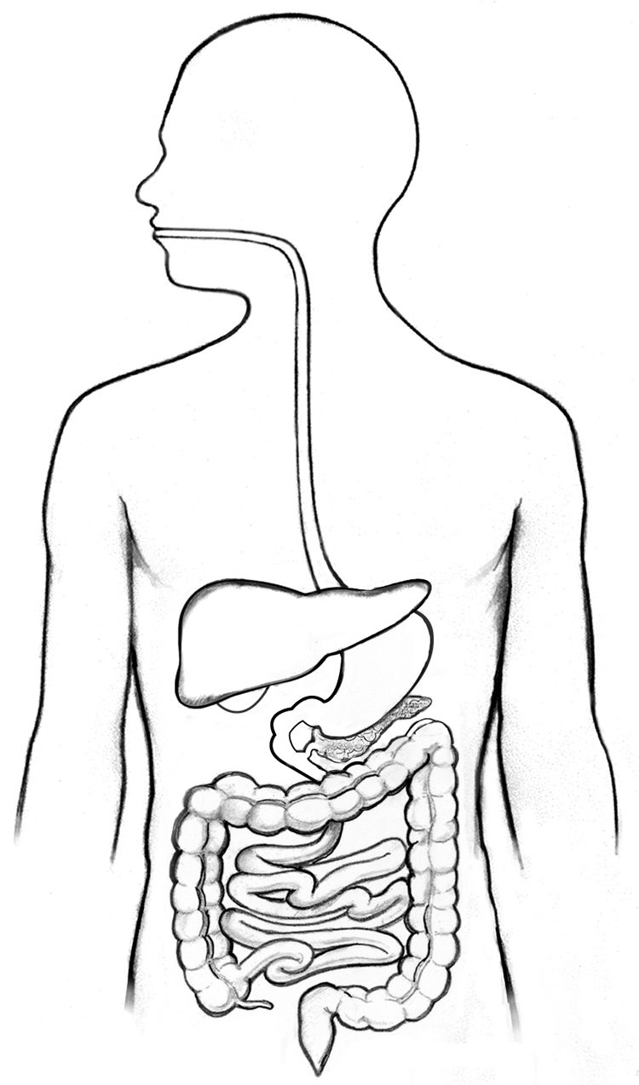
Pancreas
Large intestine
Oesophagus
Liver
Small intestine

Level 6/7
Complete the table below by describing the functions of different organs in the digestive system:

Organ in Digestion | Function
Mouth

Salivary Glands

Enzymes (In mouth, stomach and intestine)
Oesophagus

Stomach

Small Intestine

Large Intestine

Challenge – Liver

Challenge – Pancreas

Level 8/9

What are the following food molecules broken down into during digestion?

- Carbohydrates

- Proteins

- Lipids

How are the villi in the small intestine adapted to maximise absorption of nutrients?

